**Big Data Lab 4 Assignment**

In this a app was developed in android which takes the acceleration values from the sensor tag and saves onto the SDCard. The app looks like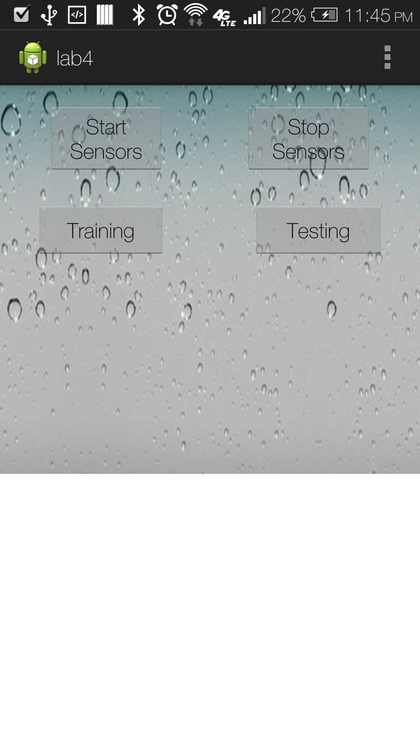

After the data is collected which are saved in the following text files: vPunch.txt(Punch Motion), vLtoR.txt(Left to Right Motion), vRtoL.txt(Right to Left Motion), vCombo.txt(Combination Motion).

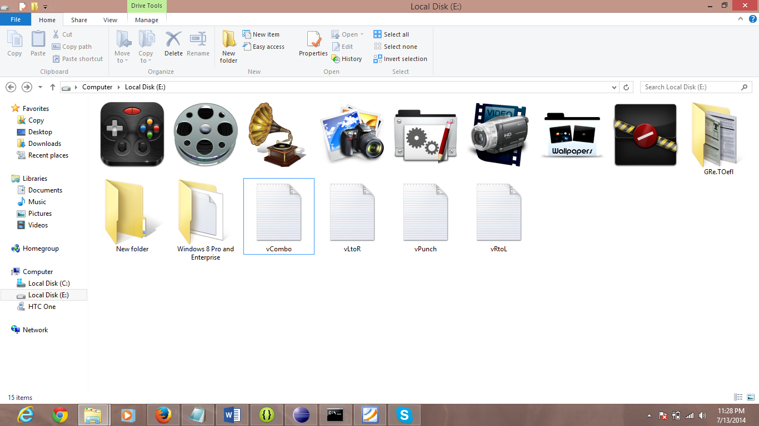

Now the webservice was called locally to convert the text file to sequence file.

<http://localhost:8080/HMMWS/jaxrs/generic/TrainFileOperation/-E:-vPunch.txt/-E:-vPunch.seq>

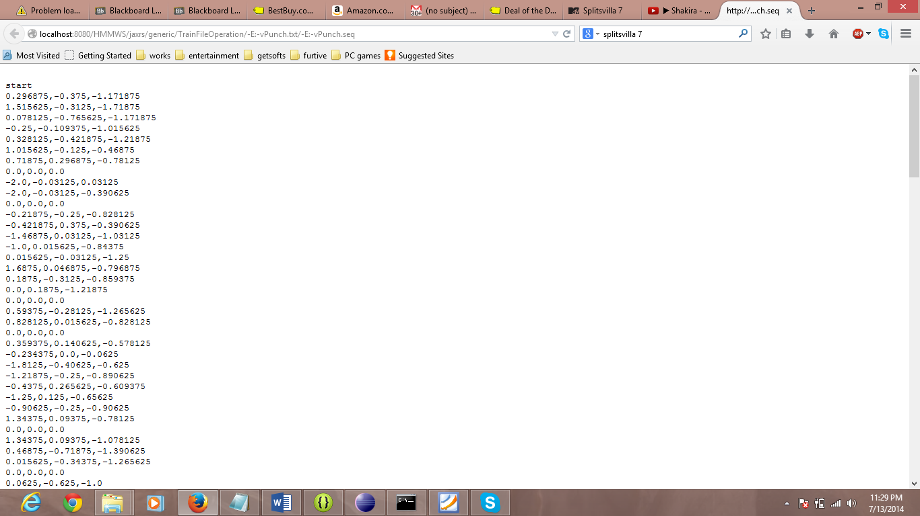

<http://localhost:8080/HMMWS/jaxrs/generic/TrainFileOperation/-E:-vLtoR.txt/-E:-vLtoR.seq>

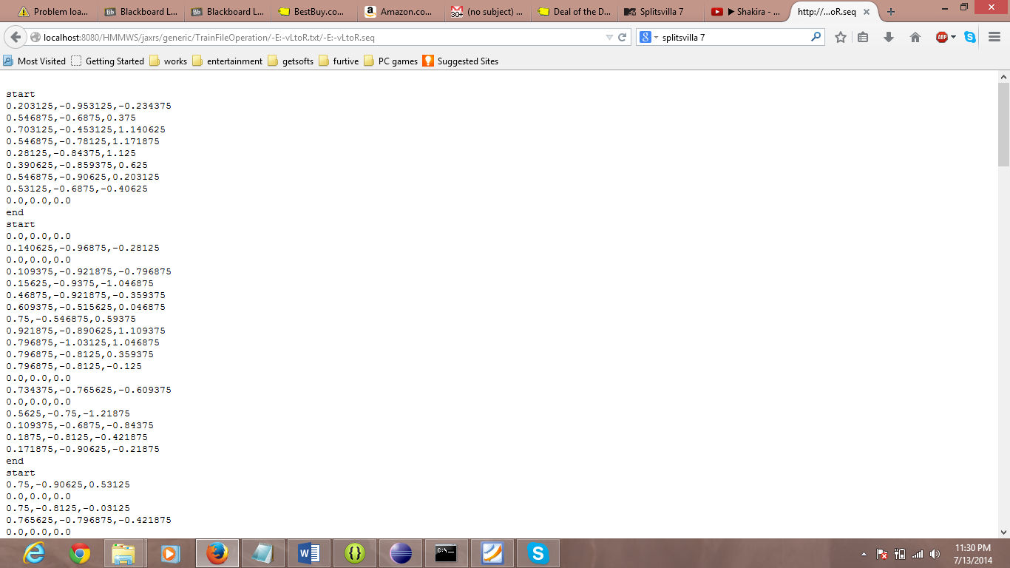

<http://localhost:8080/HMMWS/jaxrs/generic/TrainFileOperation/-E:-vRtoL.txt/-E:-vRtoL.seq>

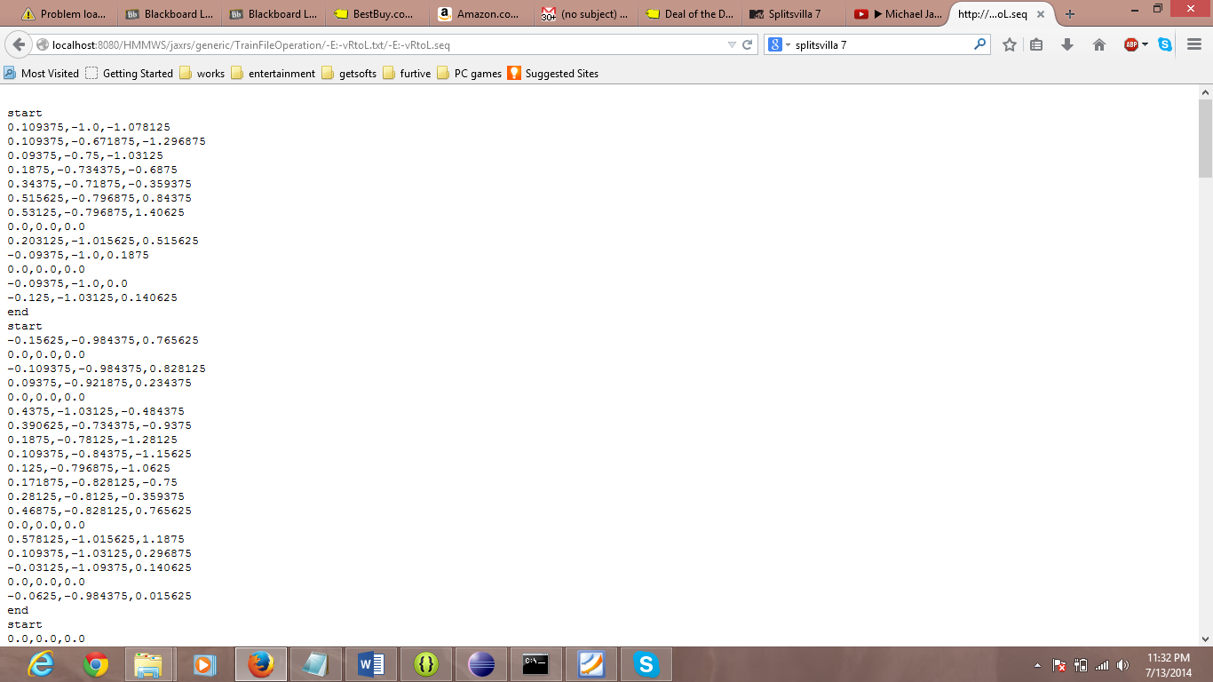

<http://localhost:8080/HMMWS/jaxrs/generic/TrainFileOperation/-E:-vCombo.txt/-E:-vCombo.seq>

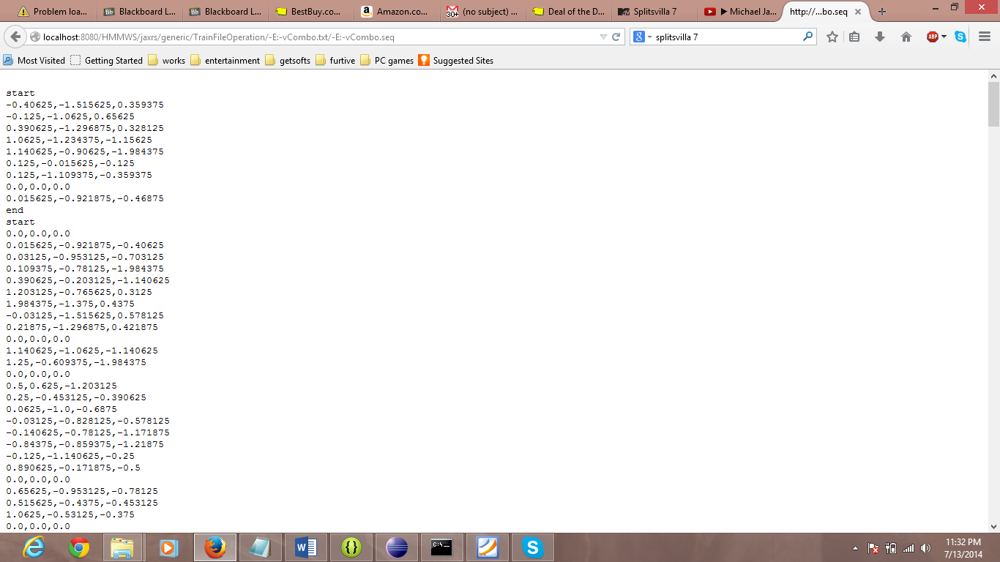

Even after calling the webservice I could find the sequence file in the Specified location as can be seen the screenshot.

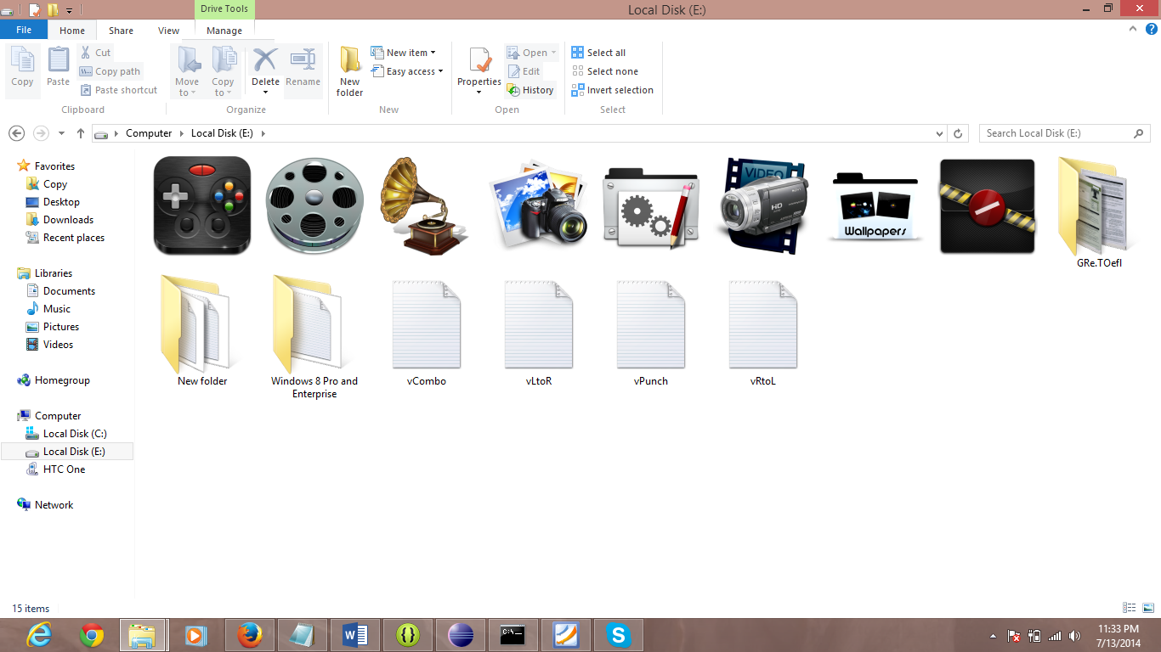

Even if the webservice hosted on cloud is used the files are not uploaded on to the Cloud as you can see in the screen shot:

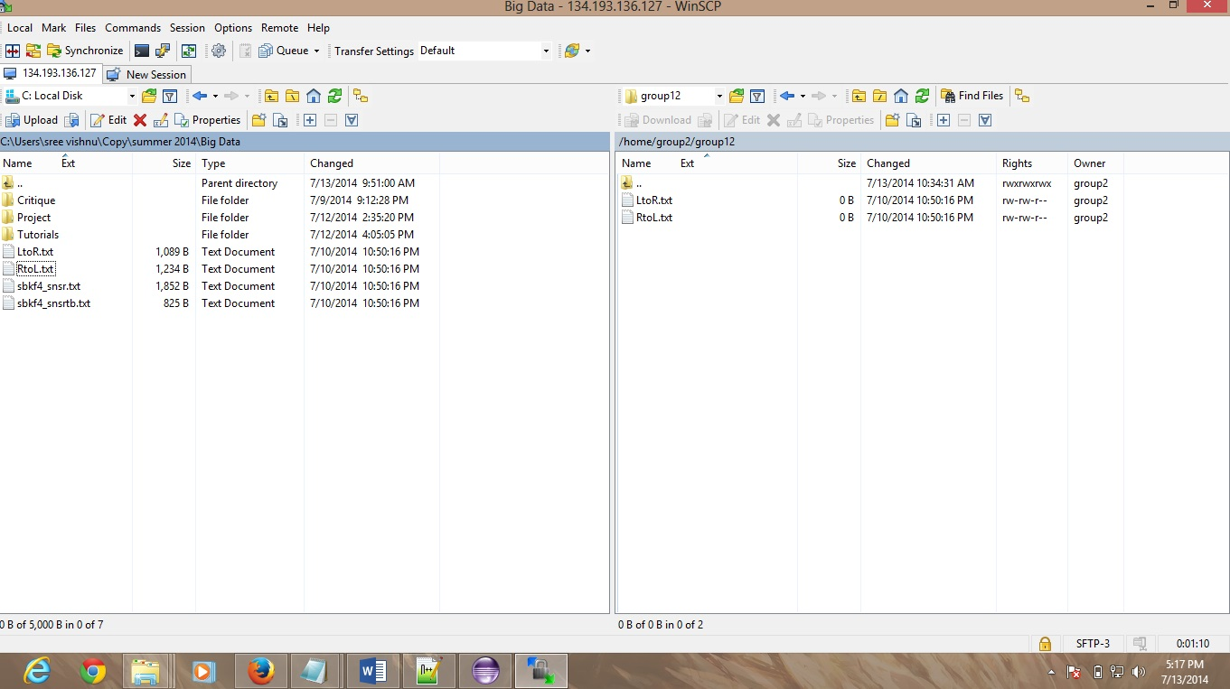

Even if the webservice is called to convert the file to sequence file no sequence file is created on the cloud.

**Sree Vishnu Satarajupalli**

**16162426**